Spring REST using Spring Boot 3 Assignments
Hello World RESTful Web Service
Objective
Write a REST service in the spring learn application created earlier, that returns the text "Hello World!!" using Spring Web Framework.
applications.properties
spring.application.name=orm-learn
# Spring Framework and application log

logging.level.org.springframework=info

logging.level.com.cognizant=debug

# Hibernate logs for displaying executed SQL, input and output

logging.level.org.hibernate.SQL=trace

logging.level.org.hibernate.type.descriptor.sql=trace

# Log pattern

logging.pattern.console=%d{dd-MM-yy} %d{HH:mm:ss.SSS} %-20.20thread %5p %-25.25logger{25} %25M %4L %m%n

# Database configuration

spring.datasource.driver-class-name=com.mysql.cj.jdbc.Driver

spring.datasource.url=jdbc:mysql://localhost:3306/ormlearn

spring.datasource.username=root

spring.datasource.password=dummypassword

# Hibernate configuration

spring.jpa.hibernate.ddl-auto=validate

spring.jpa.properties.hibernate.dialect=org.hibernate.dialect.MySQLDialect

server.port=8083

HelloController.java
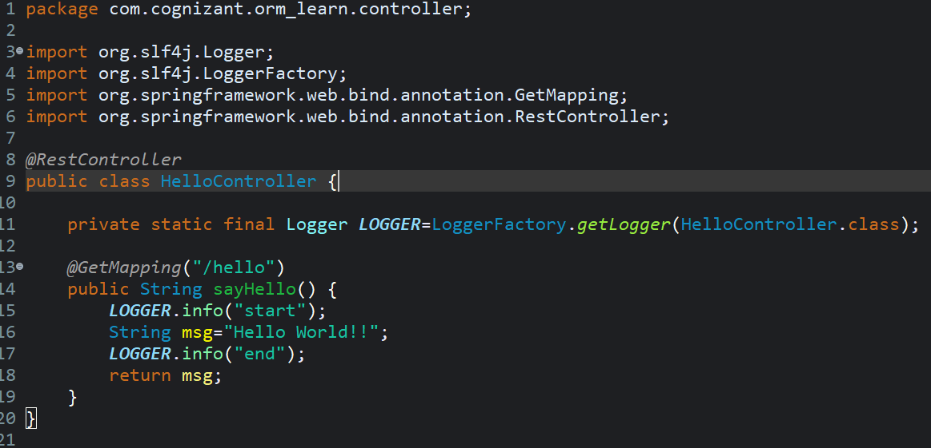
Console:
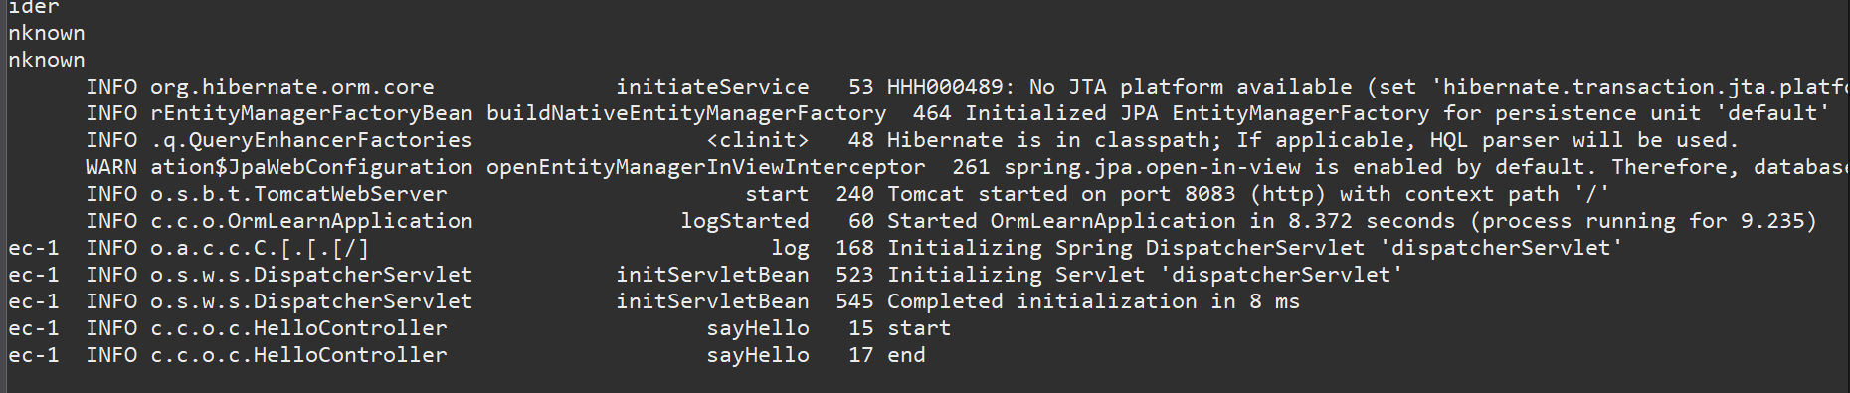

API Tester:
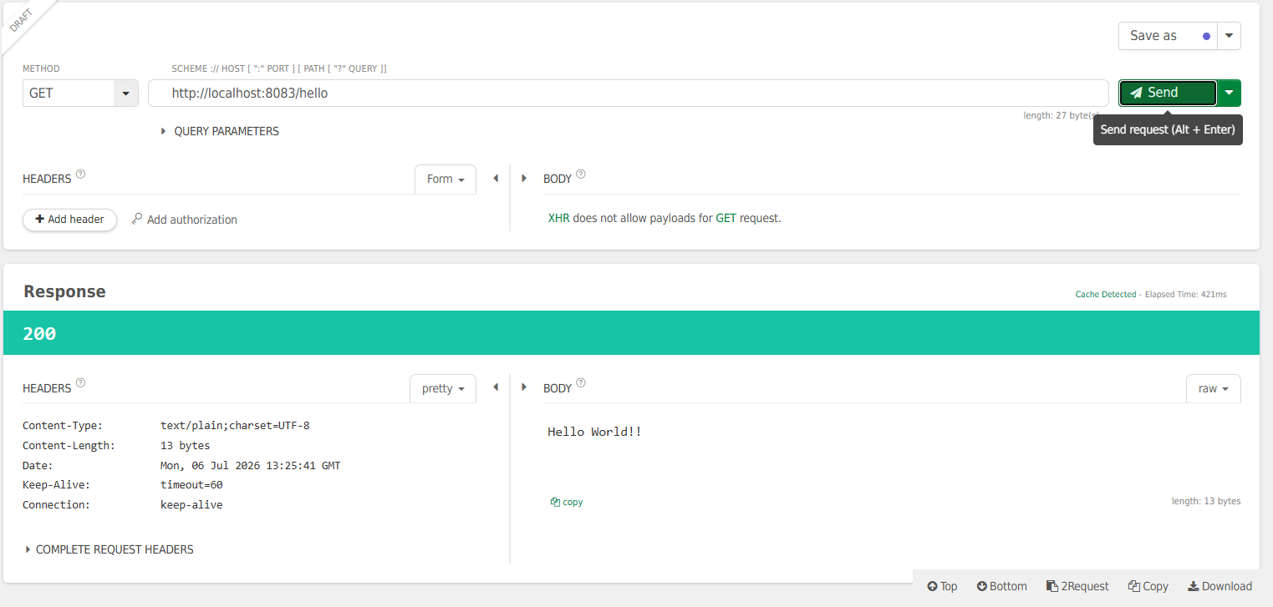

Testing in Chrome Browser:
